
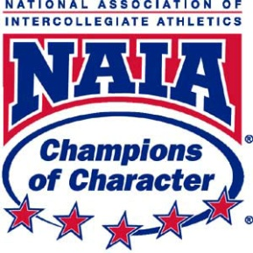

2023 Southeastern University Nike Volleyball Camp #4 Packing Suggestion

5-7 Athletic Shirts
4-6 bottoms (shorts, spandex, leggings – whatever they prefer to pay in)
3-4 pairs of socks
1-2 pairs of court shoes
1-2 pairs of kneepads
Shoes to travel in (slides, crocs, etc)
Water bottle
Cover up items such as sweatshirts, sweatpants, etc (if wanted)
Sleep clothes
Toiletries
Twin Size Sheets, Blanket or Comforter, or Sleeping Bag
Pillow
Towel for shower
Hand Towel for sink area
Snacks
Any medications (camp athletic trainer and coaches cannot administer to your camper)

*Each room has its own AC and plenty of electrical outlets
*No refrigerators or microwaves in the dorm rooms
*We will not be utilizing the pool so no bathing suit needed

